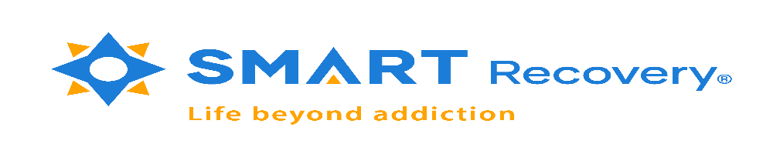

Dear Friends and Colleagues,
SMART Recovery Ireland will be hosting a Pilot: Family & Friends Meeting.
Meetings will be delivered over 10 weeks for 2hr duration.
The SMART Recovery Family & Friends programme has been designed as mutual aid for those who are affected by the addictive behaviour of someone close to them. The programme explores how participants can prioritise their own self-care and wellbeing. Participation in these initial meetings will contribute to the programme and overall delivery of SMART Recovery Family & Friends within Ireland.
SMART Recovery is an acronym for Self-Management and Recovery Training. SMART Recovery Family & Friends uses the four key points of the SMART Recovery programme. These points have been adapted to suit the needs of family and friends. The adapted points are:
1. Building and Maintaining motivation. 2. Coping Strategies. 3. Managing thoughts, Feelings and Behaviour. 4. Living a Balanced lifestyle.
The programme aims to help participants develop more effective coping strategies and to find a greater sense of fulfilment within their lives. The meetings are structured, utilising tools and exercises through information sharing and discussions that builds on their resilience.
Participants will receive a Family & Friends handbook that will provide the necessary tools and exercises.
Those who wish to avail of this program please contact:
familyandfriends@smartrecovery.ie
Regards
Ann Lacey & Caroline Mc Conville

