

Family and Friends Programme



The Programme Supports You to develop more effective Coping Strategies and find a greater Sense of Fulfilment in your Own Life. Focusing on You, the person providing the care and support, not the person with the problem behaviour.

DELIVERED ON-LINE

PROGRAMME DURATION:

8 WEEKS

2 HOUR SESSIONS

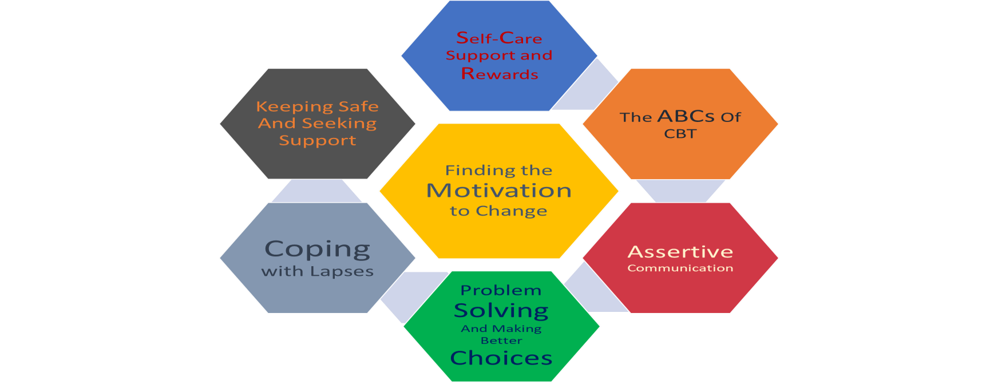

GOAL

Setting

n

g

With knowledge and Support, you can learn how to Cope with and respond to the Problem Behaviour of the person in your life, in much the same way that we learn to cope with a broad range of difficult and complex problems in our lives.

CONTACT: familyandfriends@smartrecovery.ie

087 349 0780