Free Stress Control Online Programme starts 13th April 2020
Briefing Note

HSE, Health & Wellbeing will be offering a Stress Control Online programme, commencing 13th April 2020, via Stresscontrol.org. This 3 week programme is free of charge to the public and delivered by Dr. Jim White, Consultant Clinical Psychologist, Stress Control Ltd.

Watch Dr. Christina Corbett, Senior Clinical Psychologist with the HSE, introduce the programme here.

It has never been more important for the public to have evidenced based supports from a trusted source, to help them manage and deal with the range of emotions individuals and families are experiencing at the moment. This initiative encourages participants to be their own therapist by managing their thoughts and emotions and developing techniques to help them maintain good mental health. This initiative is part of a range of measures being rolled out under the new Government’s Together Campaign which is focuses on supporting wellbeing at this unprecedented time. Please help us promote this programme to your audiences and target groups.

Schedule
There are six free sessions available to the public. Session one commences on the 13th April (Session one will repeat on Tuesday 14th). Each session will play twice a day (at 2pm and repeated at 8.30 pm) on Mondays and Thursdays beginning on the 13th April. The sessions will be led by Dr Jim White, consultant clinical psychologist.

Content
The six sessions, 90 minutes be session, will cover the following topics. Participants are encouraged to watch all sessions, but participants can join at any stage for one or more session.

Session | Date | 1st Showing | Repeated
1: What is stress? | Mon, 13th April | 2 – 3.30pm | 8.30 – 10pm
2: Controlling your body | Thurs, 16th April | 2 – 3.30pm | 8.30 – 10pm
3: Controlling your thoughts | Mon 20th April | 2 – 3.30pm | 8.30 – 10pm
4: Controlling your actions | Thurs, 23rd April | 2 – 3.30pm | 8.30 – 10pm
5: Controlling panicky feelings Getting good night’s sleep | Mon, 27th April | 2 – 3.30pm | 8.30 – 10pm
6: Boosting your wellbeing  Tying it all together  Controlling your future | Thurs, 30th April | 2 – 3.30pm | 8.30 – 10pm
*Session 1 will be repeated Tues, 14th April at 2pm and 8:30pm

How to Participate:
In order to access these sessions on line:
Users must click on http://stresscontrol.org and follow instructions about how to ‘Subscribe’ to Stress Control’s YouTube page. This is a free subscription.
Users will then receive notifications when a new session is available. You can also follow this link: https://www.youtube.com/playlist?list=PL_BKErJ_jlSQHKFtHPCRmEctDtcNCCowB

See HSE website for the outline of the programme here.

See outline of various supports provided by HSE Mental Health at this time here.

Please share this information to your networks and through your own communication channels and use #StressControlIrl.

Some suggested tweets from Sunday 12th April and to promote the session timetable above:
A new evidenced based programme Stress Control is available to you for free at the following times via stresscontrol.org. These days Managing our stress levels and encouraging those we care about to is really important. #StressControlIrl #Covid19

Calling all the busy parents out there to put a date in their diary for the Stress Control Online programme which will be available via stresscontrol.org at the following times. Let us know what you think by using #StressControlIrl #Covid19 (insert timetable image)

Here is a message for all your Whatsapp groups and for you. Take control with Stress Control online programme starting tomorrow. Go to stresscontrol.org for more details #StressControlIrl #Covid19

Don’t miss the new Stress Control Online programme at 2 and 8.30 today on stresscontrol.org . This is a proven programme to help with mild, moderate and severe levels of stress and will support your health and wellbeing. #COVID19 #StressControlIrl

Stress Control Online is highly recommended to help reduce stress and anxiety. Join the free Stress Control Online programme at the link below to learn new stress management skills and mind your mental health. #StressControlIrl #Covid19

Due to the #COVID19 crisis high levels of stress are affecting us all emotionally, mentally and physically. There is support available to help you get your stress under control. Check out our free online Stress Control programme. #StressControlIrl

Further information:
Narrator: Dr Jim White, Consultant Clinical Psychologist, Stress Control Ltd.
Dr. Jim White is an internationally recognised expert in stress management. Jim has presented at many national and international conferences and events and acted as a National Advisor to the Scottish Government. He is involved with the European Union on how to develop mental health services across Europe using interventions, including Stress Control, he has devised. Jim is a Fellow of the British Psychological Society, a Fellow of the British Association for Behavioural and Cognitive Psychotherapies, the lead CBT organisation in the UK and Ireland and had been appointed a Chartered Scientist. Jim has teamed up with the HSE to train Master Trainers of Stress Control in Ireland.
HSE Stress Control Programme
The roll out of the Stress Control programme has been a priority for the HSE under the Healthy Ireland Framework and under the Connecting for Life Suicide Strategy. Prior to COVID-19 the HSE was working across the Community Health Organisations and Hospital Groups to roll out Stress Control to the public and to staff. In the context of COVID-19 this course is now available online.

Images for sharing
Twitter images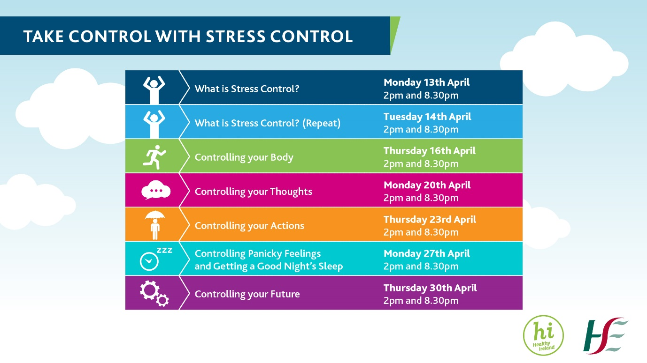
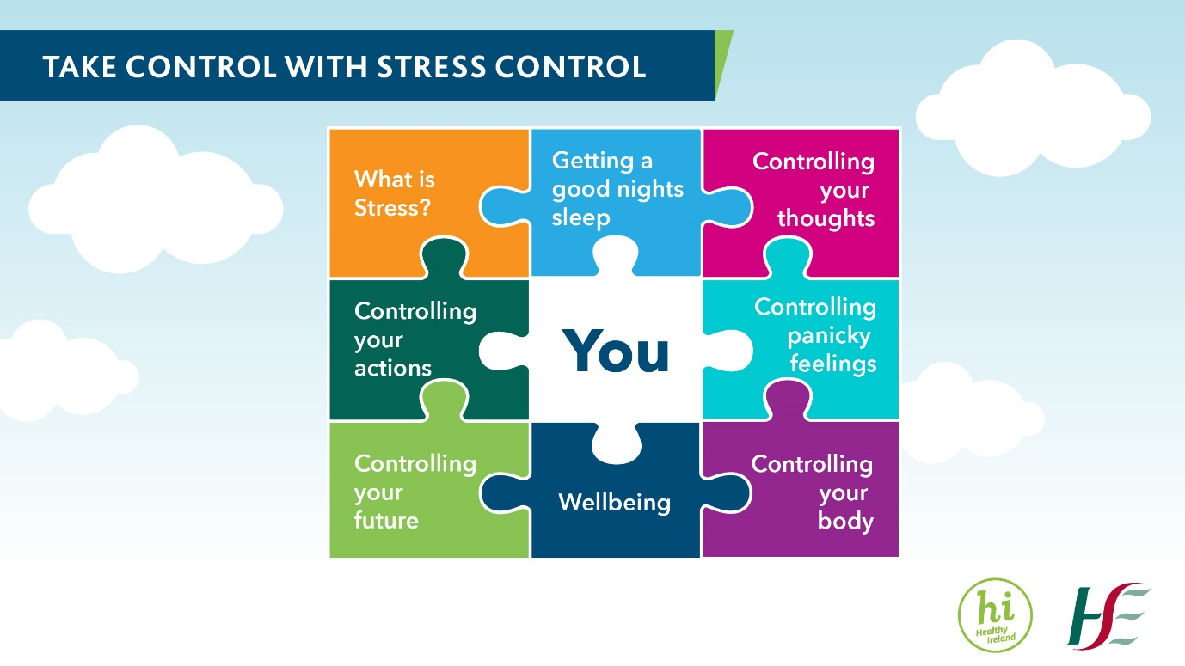
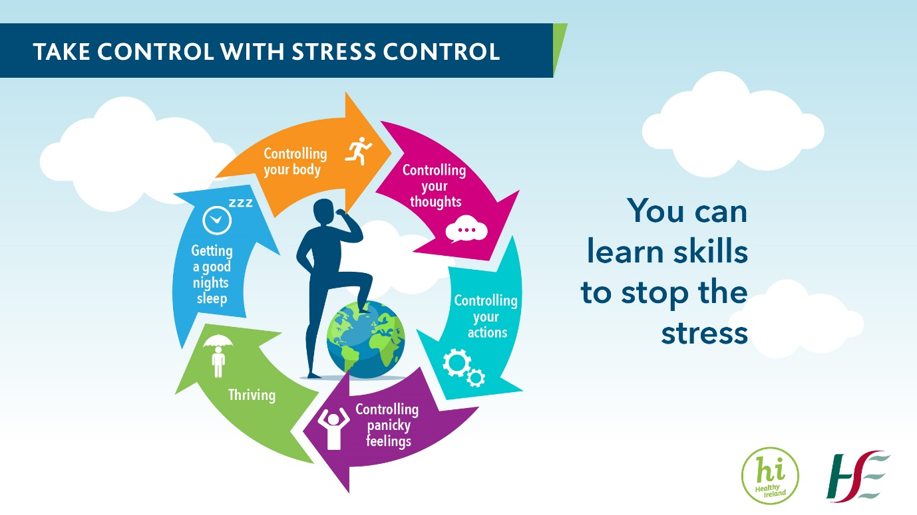

Square versions
