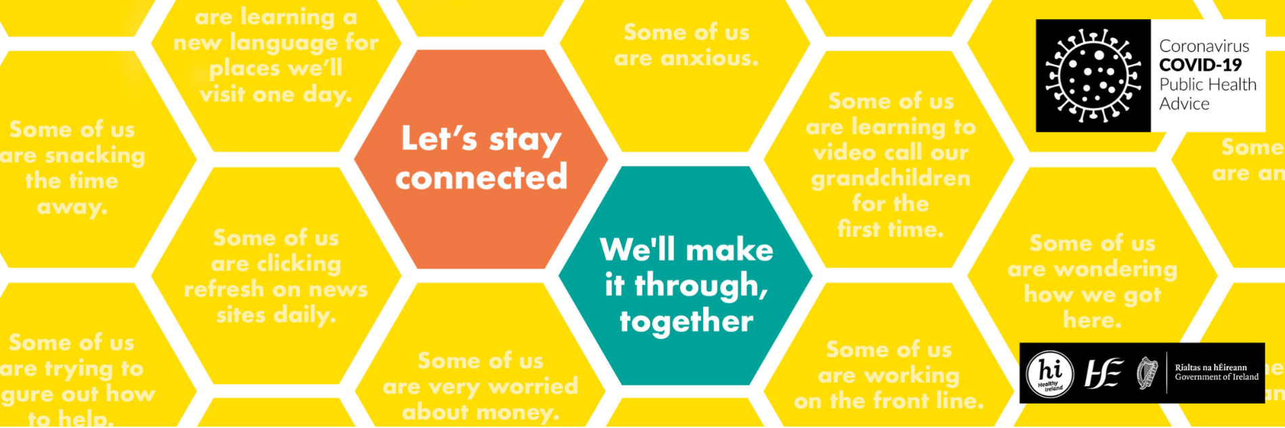

GETTING THROUGH COVID-19 TOGETHER

CAMPAIGN RATIONALE

The outbreak of COVID 19 globally is a source of significant stress, anxiety, worry and fear for many people. This arises from the disease itself, as well as from impacts such as increased social isolation, disruption to daily life and uncertainty about employment and financial security.

The Government Action Plan in response to Covid-19 acknowledges the importance of people maintaining their wellbeing and resilience to push through this unprecedented outbreak.

CAMPAIGN RESPONSE

The Department of Health and the HSE, in collaboration with key cross-Government and cross-sectoral partners, have been developing a mental wellbeing campaign aimed at offering support and resources to help deal with the stress, anxiety and isolation currently experienced by many people.

The campaign, which is hosted on gov.ie, points people to the HSE’s Your Mental Health supports and resources which include many online and telephone services, as well as providing tips and advice from cross-Government and Healthy Ireland partners on topics such as physical activity, parenting, coping with daily routines, supporting the ‘cocooned’ and getting involved in the community solidarity efforts.

CAMPAIGN CREATIVE #Together

Nothing has ever felt so abnormal in living memory. We want people to know that whatever they’re facing right now, and in whatever personal way they’re responding to this crisis … that they are not alone.
Because whilst some of us are feeling a little anxious, some of us might be feeling very worried about money and some of us might just be bored. This campaign is about uniting all of us. Bringing us together in the name of wellbeing to support us all, because ‘All of us are ‘Some of us’’

The campaign emphasises the importance of collective support and staying connected to others, and while all of us are experiencing different concerns, it highlights:

“no matter what you’re going through, let’s stay connected and make it through, together”.
#Together

Here are the briefing templates for both visual and copy posting across social media for this campaign.

IMAGERY LOCKUP

All imagery should have this overlay, it will need to be applied in Photoshop or InDesign at the design stage. Keep in mind this overlay when selecting or designing imagery for use in supporting the campaign.

COPY BRIEFING:

To amplify and extend the awareness of the campaign, we ask that you try to use the same copywriting convention for each social post. The campaign targets everyone and requires a mass awareness campaign to reach as wide of an audience as possible. Our creative and media approach reflects this. We will use each channel and cross-sectoral partner to appeal to a different aspect of the stress, anxiety and worry for people, based on your particular niche.

Below is the social post convention and sign-off which we would like each partner to use for consistency.

1. CONVENTION: Some of us are….
Examples:

Some of us are wondering what to do with all the extra pasta they bought
Some of us are constantly refreshing the news
Some of us are feeling the pressure on their family life

In our experts series with Karl Henry etc. we’ll use this as an intro

“Some of us are finding it hard to keep active.”

3. SIGNPOST: Visit gov.ie/together for advice, ideas and support for your physical and mental wellbeing, for all of us.

Important to sign off with the resource information.

4. HASHTAG: #Together

COMMUNICATION CHANNELS:
The campaign will run over the coming months on national and local radio stations across all ROI stations, as well as appearing on online video players and on-demand. The campaign will also be supported by national and local publicity as well as digital and social advertising.

SUPPORTING THE CAMPAIGN:
In addition to your own communication activities around Covid-19 and Wellbeing we welcome your support by including the new wellbeing branding attached.

As supporters we ask that you:
• Support the key messages
• Amplify and extend the awareness of the campaign messages through your own activity

KEY MESSAGES:
We wish to encourage anyone who is struggling, to reach out and avail of range of online and phone supports, provided by the HSE and our partners, that can be found on YourMentalHealth.ie.

For people who need help managing at home the following are the top ten pieces of advice

1. Stay connected - keeping in touch with people, and talking about how you feel, can really help
2. Create a routine - if you’re at home, getting up, staying active and eating at regular times helps you feel more in control
3. Stay Active - whether you’re indoors or can still go out for exercise, move around as much as you can
4. Have a healthy diet - this advice never changes - but eating well really does help your mood
5. Reduce stress - you’re not working from home - you’re at home, in a crisis, trying to work or homeschool children. There’s lots of great ways to reduce stress.
6. Stop scrolling – switch off - it’s good to keep informed but try to limit how much news you’re following and take a break every day
7. Get creative - try some activities like painting, singing, dance. No one is watching.
8. Help others - see if your neighbours need any help with shopping or medicines
9. For those cocooning – look for supports from the Community Call lines in each area
10. Visit gov.ie/together for more Sources and Services that can help

