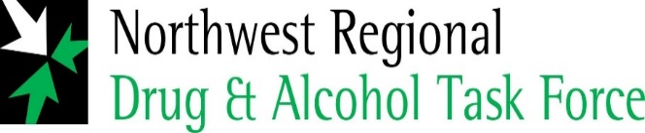

**Press Release**

As part of our ongoing work in implementing the **S*ligo City Alcohol Strategy, 2018 – 2023***, the Sligo Healthy Ireland project in conjunction with the ***North West Regional Drug & Alcohol Task Force*** have developed a range of health promotion signs giving clear and practical messages around low risk drinking guidelines which have been affixed to numerous bottle banks in Sligo town and environs.

By implementing this action, we are adding value to the Strategy and in doing so, creating public awareness around the link between alcohol and health related issues. It is incumbent on us a Task Force to educate and inform the general public that alcohol is **not** an ordinary commodity but one that contributes to a range of social and health problems.

We would like to thank the various agencies, in particular Sligo County Council for their involvement with this initiative - partnership working is key in making Sligo a safer and healthier to place for all of its citizens.

If you require any further information in relation to the above, please contact:

Sean O’Connor, Coordinator, Sligo Development Centre, Cleveragh Road, Sligo

Phone: 087 9959091/071 915120/drugtaskforce@nwdrugtaskforce.ie/ [www.nwdrugtaskforce.ie](http://www.nwdrugtaskforce.ie)

