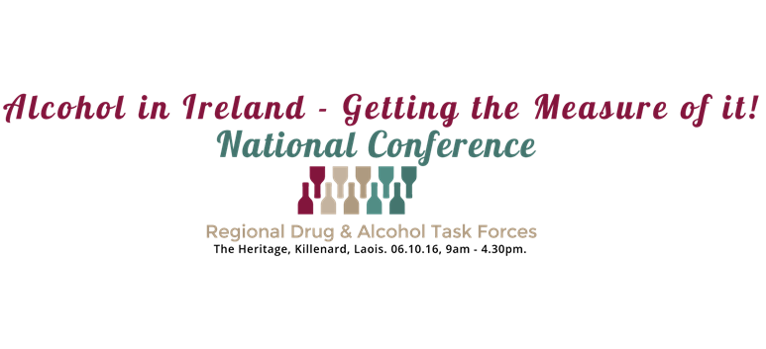

***The aim of the conference is to build the capacity of Drug & Alcohol Task Forces and their key partners to provide evidence-based responses to alcohol problems in the communities they serve.***

Conference Programme

**9.00am Registration & Refreshments.**

**10.00am Welcome & Opening Address by Conference Chairperson.**

*Professor Joe Barry, Chair of Population Health Medicine, Trinity College Dublin.*

**10.10am Conference Address:**

*Chairperson RDATF Co-ordinators’ Network.*

*Marcella Corcoran Kennedy, T.D., Minister for Health Promotion.*

*Ms Susan Scally, Principal, Drugs Policy Unit, Department of Health.*

**10.30am Treatment & Rehabilitation Responses to Alcohol Problems: Putting Together a Coherent National Response.**

*Dr Shane Butler, Associate Professor at School of Social Work and Social Policy, Trinity College Dublin.*

**11.10am Problem Alcohol Use in the Irish Population.**

*Dr Suzi Lyons, Senior Researcher, NHIS, Health Research Board.*

**11.30am BREAK**

**11.40am The SAOR Model of Alcohol Screening and Brief Intervention.**

*Mr James O’Shea, Director of Nurse Education (Mental Health).*

**12.00pm HSE Alcohol Programme.**

*Ms Suzanne Costello, Acting HSE Alcohol Programme Lead.*

**12.10pm Irish drinking patterns and behaviours - ‘Thinking About Our Drinking’.**

*Dr Adam R Winstock, Consultant Psychiatrist & Addiction Medicine Specialist, Founder Global Drug Survey.*

**12.40pm Lunch**

**1.40pm Alcohol through the Ages: From the Cradle to the Grave - What we can do & what else needs to be done?**

*Dr Adam R Winstock, Consultant Psychiatrist & Addiction Medicine Specialist, Founder Global Drug Survey.*

**4.20pm Closing comments & finish***.*

Biographies of Speakers

|  |  |
| --- | --- |
| **Professor Joe Barry**  Professor Joe Barry qualified in Medicine from University College Cork and in Public Health from the University of London. He is Professor of Public Health Medicine in Trinity College, Dublin and a Consultant in Public Health Medicine with the Health Service Executive. He has worked in the drug and alcohol areas for 25 years, as a researcher and advocate and is currently Chair of the North Inner City Local Drug and Alcohol Task Force and a board member of Alcohol Action Ireland. He is also a member of the National Advisory Committee on Drugs and Alcohol and was a member of a National Drugs Strategy Team for 12 years. |  |

|  |  |
| --- | --- |
| **Dr Shane Butler**  Dr Shane Butler PhD is a Fellow Emeritus of Trinity College Dublin, having recently retired from his position of Associate Professor at Trinity's School of Social Work and Social Policy. His teaching and research interests are mainly in the area of drug and alcohol policy, and he was Course Director for the M.Sc. in Drug and Alcohol Policy. |  |

|  |  |
| --- | --- |
| **Dr Suzi Lyons**  Dr Suzi Lyons PhD currently is the Senior Researcher, National Health Information Systems at the Health Research Board, responsible for the National Drug-Related Deaths Index (NDRDI) and the National Drug Treatment Reporting System (NDTRS). Dr Lyons has a Masters in Community Health from Trinity College Dublin and a PhD in Public Health and Epidemiology from University College Dublin. She is an alumni of the European Programme in Intervention Epidemiology Training (EPIET). Previously she has worked as an epidemiologist with the World Health Organisation. She also spent several years working overseas with Medecins Sans Frontieres (MSF). | SLyons1 |

|  |  |
| --- | --- |
| **Ms Suzanne Costello**  Suzanne is CEO of Alcohol Action Ireland and a member of the Healthy Ireland Council. She joined Alcohol Action Ireland from the Samaritans in 2014, where she had been Executive Director for Ireland for six years. Suzanne is currently working on the development of the HSE Alcohol Programme to support the implementation of legislative measures contained in the Public Health (Alcohol) Bill 2015. Suzanne holds a B.Soc.Sci from UCD and an MBS from UCD Michael Smurfit Graduate Business School and is a member of the Royal Society of the Arts (UK). |  |

Biographies of Speakers cont…

|  |  |
| --- | --- |
| **Mr James O’Shea**  MA (Supervision), MA, Hdip (Education), BSc (Counselling & Psychotherapy), HGdip (Counselling & Psychotherapy), Prof dip (Addiction Counselling), Professional dip (Mindfulness Teaching – MBSR/MBCT), Registered Nurse(RPN, RGN – NMBI), ACI (Accred), BACP (Reg), MINT Member. James holds a national lead post as Director of Nurse Education (Mental Health) with the Office of Nursing and Midwifery Services Director & Mental Health Services in the HSE. He has held previous management roles in Nurse Education and Training and Development within Addiction Services. He is a trainer in CBT, Motivational Interviewing and Mindfulness.  His clinical experience traverses Psychiatric Nursing, Addiction Counselling, Counselling and Psychotherapy and Clinical Supervision.  He is co-author and developer of the SAOR model of Brief intervention. He has numerous peer reviewed and health service publications relating to CBT, Clinical Supervision and Brief Intervention.  He is along with colleagues currently finalising the second edition of the SAOR Model. |  |

|  |  |
| --- | --- |
| **Dr Adam Winstock**  Adam is a Consultant Addiction Psychiatrist at the South London and Maudsley NHS Trust and Honorary Senior Lecturer at the Institute of Psychiatry, Kings College London. He is also Director of Global Drug Survey [www.globaldrugsurvey.com](http://www.globaldrugsurvey.com) and architect of the brief intervention and screening alcohol app, the Drinks Meter [www.drinksmeter.com](http://www.drinksmeter.com). |  |