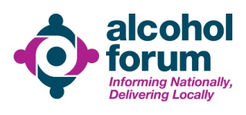
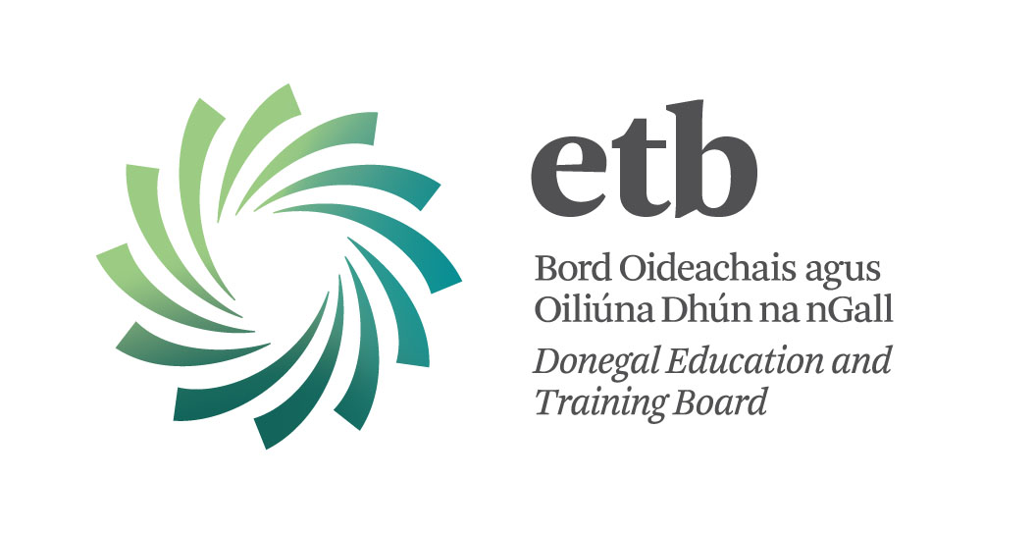

Training Calendar
July–December
2016

Alcohol & other Drugs Related Training

Sligo – Leitrim
Donegal

Month | Dates | Training | Location | MAX  Places | Page
June | 16th | Introduction to Hidden Harm | Leitrim | 20 | 7
June | 23-24th | Essential Group Facilitation Skills | Sligo | 16 | 8
July | 4-8th | Teacher Training/ in-service | Sligo | 20
July | 11-15th | Teacher Training / in-service | Donegal | 20
July | 19th | Introduction to Hidden Harm | Donegal | 20 | 7
Aug | 22nd-25th | Teacher Training / in-service | Monaghan | 20
Sep | 14th | SAOR: Screening & Brief Interventions | Leitrim | 16 | 5
Sep | Starts 15th | QQI/ Fetac level 5 Community Addiction Studies | Donegal | 20 | 4
Sep | 28th | Adolescence and Substance Misuse: Working with Young people on Substance Misuse / Early Intervention | Leitrim | 20 | 6
Oct | 7th | (NPS) New Psychoactive Substances | Sligo | 20 | 9
Oct | 14th | SAOR: Screening & Brief Interventions | In-service  Sligo | 16 | 5
Oct | 11th/12th | Introduction to Motivational Interviewing | Donegal | 20 | 10
Nov | 11th | SAOR: Screening & Brief Interventions | In-Service  Sligo | 16 | 5
Nov | 16th | Adolescence and Substance Misuse: Working with Young people on Substance Misuse / Early Intervention | Donegal | 20 | 6
Dec | 6/7th | Introduction to Motivational Interviewing | Donegal | 20 | 10

Booking forms:

1. Individual Booking Form pg. 11

2. Request for ‘in-service’ training pg. 12

3. QQI – Level 5 in Community Addiction Studies pg. 13

Training Calendar:

The training calendar offers a range of courses in the field of alcohol and other drugs. Individuals can book the training by filling in the ‘ Individual Booking Form’ (pg.11) at the back of this document and emailing it or posting it. Training is available to wide range of professionals and community & voluntary sectors.

Tailored training:

The option of requesting tailored “in-service’ training for your services and organisations is available. Requests will be accommodated to the best of our ability, where possible. The “Request for In-Service Tailored Training Form” is available at the back of this document (pg.12). Call Christina for a brief discussion on your training needs.

Trainer Profile:
Christina Murray-McELeney completed her BSc Hons Degree with University of Ulster as part of that she studied addictions; she is an educational specialist in the field of alcohol & other drugs having completed her Post Graduate Specialist Diploma in Teaching, Learning & Scholarship with University of Limerick. Christina has been voluntarily undertaking courses herself annually for the last 18 years. She has lectured
& guest lectured for eight years in various third level institutions namely University of Limerick, North West Regional College, Letterkenny IT and Sligo IT. Christina designs, develops and delivers a range of education & training in the field of alcohol & other drugs and has written third level modules. She works in partnership with the Alcohol Forum and HSE West (Donegal) and North West Regional Drug and Alcohol Task Force on specific & various projects to ensure the continuance of alcohol & other drugs training & education in the region. She is employed by Donegal Education & Training Board and is funded by North West Regional Drug & Alcohol Task Force (NWRDATF). Christina is a member of the National Addiction Training Programme (NATP), the Alcohol Forum Training & Education Sub-group; Short Life group Alcohol & Pregnancy Letterkenny University Hospital; Short Life group Alcohol Advisory for Schools; Strengthening Families Programme Advisory group; Prevention & Education Sub-group of NWRDATF, and a member of Donegal Education & Training Board Education Pillar. Christina is responsible for coordinating alcohol & other drug education & training in the North West Region. Other trainers may also engage in the delivery of training in the region.

QQI / Fetac Level 5 in Community Addiction Studies
Course Duration: 54 hrs. taught  96 hrs. self-directed learning | START DATE:  15th September 2016-Donegal
Who should attend?

For those that come into contact with alcohol and other drugs as part of their work / volunteering. Counsellors, Social workers, teachers, family support workers, nurses medical
& psychiatric, employment support staff, probation, Gardai among others.
Location: DONEGAL | Venue: Letterkenny
Number of places available: 20 | Trainer: Christina Murray-McEleney
Course Description:

This programme module aims to create awareness of drug/alcohol related issues and impacts on the individual, families and local communities while developing a shared understanding of effective, evidence based community& statutory responses.
Course Content: A comprehensive module on all aspects of alcohol & other drugs misuse within communities.
Learning Outcomes

- Understand and explain the process of addiction
- Outline the impact of Substance Use Disorder on individuals, families & communities
- Identify key agencies and supports for individuals & families
- Critically analyse media responses
- Critically reflect on personal values and belief systems
Certification / Accreditation:

QQI / Fetac Level 5 Certificate Component.

4.

SAOR: Screening & Brief Interventions (SBI)
Course Duration: 1 day | Dates: 14th Sept - Leitrim  14th Oct - in service Sligo  11th Nov - in service Sligo
Who should attend?
Staff who have occasion to ask people about their alcohol use. This could include workers from social care, family support, employment support, vocational training, criminal justice, probation, education, housing support and general health care services among others.
Location: Sligo / Leitrim | Venues: TBC
Number of places available: 16 | Trainer: Christina Murray-McEleney
Course Description: A Brief intervention is amongst the most effective of psychosocial treatments across a range of health related behaviours. It’s a short intervention and consists of a helpful conversation in relation to a person’s alcohol consumption. A substantial body of literature exists which supports the use of a brief intervention in a range of health care settings to be effective in the reduction of problem alcohol consumption. The Steering group report on a Substance Misuse Strategy recommends that SBI training be extended to community, voluntary, health, social and criminal justice settings such as: Health clinics and community-based health services, Community and voluntary services, Mental health services, Educational, criminal justice and other community-based initiatives, Youth and sports organisations; Later life services.
Course Content: Evidence for the effectiveness of SBI for Alcohol and drug-related presentations to health, social care and other settings provision of an overview of the SAOR model of intervention for problem alcohol and drug use . Establishing a supportive working relationship with an individual when asking about their alcohol use and how to screen for alcohol use . Deliver a structured brief intervention based upon the SAOR model.
Learning Outcomes
- Critically discuss problem alcohol and drug use as it impacts their current work or area of practice.
- Demonstrate an enhanced knowledge and awareness of contemporary models of screening and brief intervention for problem alcohol and drug use
- Identify problem alcohol and drug users who present to health, social care settings
- Utilise the SAOR model of Screening & Brief Intervention (SBI) in practice based scenarios
- Discuss the application of the SAOR model of screening and brief intervention for problem alcohol and drug use into their practice
- Access useful links and reference materials for further reading and research
Certification / Accreditation:
A certificate of attendance will be awarded on completion of the training.

Adolescence and substance Misuse: Working With Young People on Substance Misuse Issues / Early Intervention
Course Duration: I day | Dates : 28th September - Leitrim 16th November -Donegal
Who should attend?
For those that come into contact with young people as part of their work or voluntary activities alcohol and other drugs as part of their work / volunteering., Social workers, teachers, family support workers, nurses, employment support staff, probation, youth workers Gardai among others.
Location: Leitrim & Donegal | Venue: TBC
Number of places available: 20 | Trainer: Christina Murray-McEleney
Course Description:
This course aims to create awareness of drug/alcohol related issues and young people The impact of substance misuse on the young person, families and local communities
Course Content: A comprehensive overview on adolescence and substance misuse with skills development on early intervention
Learning Outcomes
- Understand teenage brain development
- Understand risk and protective factors
- Outline the impact of Substance Use Disorder on young people, families & communities
- Approach alcohol & drug issues from an informed perspective
- Provide an early brief intervention for alcohol or other drug use
- Identify key agencies and supports for young people experiencing difficulties
Certification / Accreditation:

A certificate of attendance will be awarded on completion of the training.

Introduction to Hidden Harm and the impact of substance Misuse on children and families
Course Duration: 1 day | Date: June 16th Leitrim  July 19th Donegal
Who should attend?
Individuals that are coming into contact with Alcohol & Drug issues. Workers/Volunteers who wish to gain knowledge on alcohol ,other drugs and their effects. People with an interest in this general area.
Location: Sligo, Leitrim | Venues: TBC
Number of places available: 20 | Trainer: Christina McEleney
Course Description: Parental Substance misuse has considerable impact on children and families. Children have a right to be protected from harm, safe from violence and neglect ; treated with love , care, respect and have their wishes taken into account on matters affecting them. Parental Misuse of substances can often result in reduced parenting capacity,unpredictable behaviour, inconsistent parenting, stigma for the family, physical and emotional absence ,possible criminal behaviour.
Course Content:

Introduction to the impact of problem alcohol & other drug use on parenting capacity
- Understand the interface between alcohol & other drug use domestic violence, mental health issues and the impact on family functioning
- Understand familiar drinking patterns, recreational use weekend bingeing, self-medicating, Dependent use , and their possible impact on children
Learning Outcomes:

- Demonstrate a new understanding of problem alcohol & drug use on parenting capacity
- Critically examine personal values and belief systems
- Gain knowledge on the impact on children and family functioning in the context of problem alcohol or other drug use
Certification / Accreditation: A certificate of attendance will be awarded on completion of the training.

Essential Group Facilitation Skills
Course Duration: 2 days | Date: 23rd-24th June
Who should attend?
This course is aimed at those working in the Community/Voluntary/Drugs/Alcohol sector that are involved in or plan to become involved in the facilitation of a range of groups.
Location: SLIGO | Venue: TBC
Number of places available: 16 | Trainer: Christina McEleney
Course Description: Facilitation is the theory and practice combined of working with people. Facilitation enables and empowers people to carry out a task or perform an action. A group facilitator uses certain skills in a process which allows the individuals/group reach their decision/ set their goal/learn a skill or what ever the task at hand might be. Facilitation is a developmental educational method which encourages people to share ideas, resources, opinions and to think critically in order to identify needs and find effective ways of satisfying those needs.
Course Content:
- To evaluate, recognize and put into practice the theory & practice of group work founded on the principles and values of group facilitation
- How to organise, plan, run and facilitate and evaluate group sessions with parameters, boundaries and group agreements
- Identify power, conflict and lack of participation in a group and how best to manage difficult situations
- Develop an insight into ethical behaviour as a facilitator and the use of your own power in the facilitator’s role
Learning Outcomes:

- Understanding of group task, explicit processes and implicit processes
- Understand influence and power dynamics within a group
- Become an ethical group facilitator
- Plan, provide and manage and evaluate a group session
Certification / Accreditation:
A certificate of attendance will be awarded on completion of the training.

NEW PSYCHOACTIVE SUBSTANCES (NPS)
Course Duration: 3 HRS | Date: Oct 7th
Who should attend?
Individuals & Professionals who wish to gain knowledge on the New emerging psychoactive substances ; An Garda Siochána, Drug Services, Social Work, medical staff, probation staff, prison staff, teachers, youth workers, third level health & social care students, among others.
Location: Sligo | Venue: TBC
Number of places available: 20 | Trainer: Christina McEleney
Course Description: This training will provide an insight into the new and emerging trends in drug use as well as build on existing knowledge of psychoactive substances.
Course Content:

- Overview of new emerging psychoactive substances
- Outline main substances involved in these trends and the reasons for same
- Establish a link between trends in use and social, environmental, physical, mental and individual factors
- Assess the risks involved in these trends
- Explore the implications of use Identify
Learning Outcomes:

- Identify new emerging drugs
- Understand the range of variants of NPS
- Examine online availability
- Understand NPS in respect of current legislation
Certification / Accreditation:
A certificate of attendance will be awarded on completion of the training.

INTRODUCTION TO MOTIVATIONAL INTERVIEWING
Course Duration: 2 days | Date: 11th& 12th October Leitrim 6th & 7th December Sligo
Who should attend?
This course is aimed at those working in the Community/Voluntary/Drugs/Alcohol sector that are involved in or plan to become involved in the facilitation of a range of groups.
Location: | Venue: TBC
Number of places available: 16 | Trainer: Christina McEleney
Course Description:
Motivational Interviewing is a person-centred conselling style which aims to support the client in addressing the common problem of ambivalence to change. This two day workshop aims to provide participants with a sound introduction to the theory & skills of MI.
Course Content:
- The Spirit of MI
- Conversations about change
- The four processes of MI
- Core Interviewing Skills
Responding to sustain / change talk
- Express Empathy
- Develop Discrepancy
- Roll With Resistance
- Support Self-Efficacy
Learning Outcomes:
- To introduce Motivational Interviewing
- To build and expand on existing skills
- To enhance confidence in working with people
- To become familiar with the principles of MI
- To provide a sound understanding of MI & how it works

Certification / Accreditation:
A certificate of attendance will be awarded on completion of the training.

Important Notes:

Each training session is subject to numbers. The training calendar is subject to change.
In-service tailored training can be designed and delivered ‘in –service’ by request. If you have a group of 10 participants, training can be delivered to your organisation ‘in-house’ on your premises or a premises that you organise.

There are 3 different booking forms:

Individual booking form – use this form for any of the short courses

Request for tailored ‘in-service’ training – use this form for your organisation to request in-service training. A minimum of 10 participants are required. The organisation provides the venue.

QQ1 level 5 Community Addiction Studies: Use this form if you wish to apply to do this course.

Booking is essential TWO weeks before any short courses, booking is on a first come first served basis. Book early, as numbers are limited.

To book any of the training sessions, fill in the Booking Form; you can locate this form at the end of this document.
Email to: christinamceleney@donegaletb.ie
or post the form to: Christina Murray-McEleney, Donegal ETB, Ard O Donnell, Letterkenny, Donegal.
Contact number for Christina : 0879369312

Individual Booking Form
Name of Course
Date & Location of Course
Individual applicant details
Name |  | DOB:
Tel / Mob
Address
Email Address
What organisation do you work / volunteer with ?
Name of contact person
Oganisation details (briefly describe your organisation and what it does)
Contact Tel / mob
Contact email address
Application for Training
Have you previously completed any alcohol and other drugs training? (Please describe)
What do you hope to learn from this training?

(Please Describe)
email this form to: christinamceleney@donegaletb.ie
Post this form to: Christina Murray-McEleney, Coordinator Alcohol & Other Drugs Education & Training , NW region, Donegal ETB, Ard O’ Donnell, Letterkenny, Donegal.

Request Form: Tailored ‘in-service’ training

Course requested
Possible dates
Number of participants
venue
Organisation details
Name of contact :
Oganisation details (briefly describe your organisation and what it does)
Contact Tel / mob
Contact email address
Please provide a much detail as possible for your particular request
What other alcohol / drug training has your organisation completed?
Please provide a rationale for the training you request
Post to: | Christina Murray-McEleney, Coordinator Alcohol & Other Drugs Education & Training , NW region, Donegal ETB, Ard O’ Donnell, Letterkenny, Donegal.
Email to: | christinamceleney@donegaletb.ie

QQI LEVEL 5 COMMUNITY ADDICTIONS
APPLICATION FORM
NAME
DATE OF BIRTH: |  |  | PPSN:
ADDRESS:
TEL: |  |  | MOBILE:
EMAIL ADDRESS:
Have you previously completed any other alcohol & other drugs training courses?
Please list ➔
Educational attainment
Qualifications

Please list ➔
Do you work or volunteer for an organisation that come into contact with alcohol or other drugs issues?
Please explain ➔
Please provide a personal statement detailing your reason for applying for this particular course:-
(you may use a separate sheet if required)
ACCESS TO A COMPUTER & COMPUTER LITERACY ARE ESSENTIAL FOR THIS COURSE
Email this form to: christinamceleney@donegaletb.ie
Post this form to : Christina Murray-McEleney , Donegal ETB, Ard ODonnell, Letterkenny, Co. Donegal
Closing Date for Applications : 31st August 2016. Start date of the course: Thursday 15th September 2016

