QQI / fetac level 5
Community Addiction Studies
SLIGO
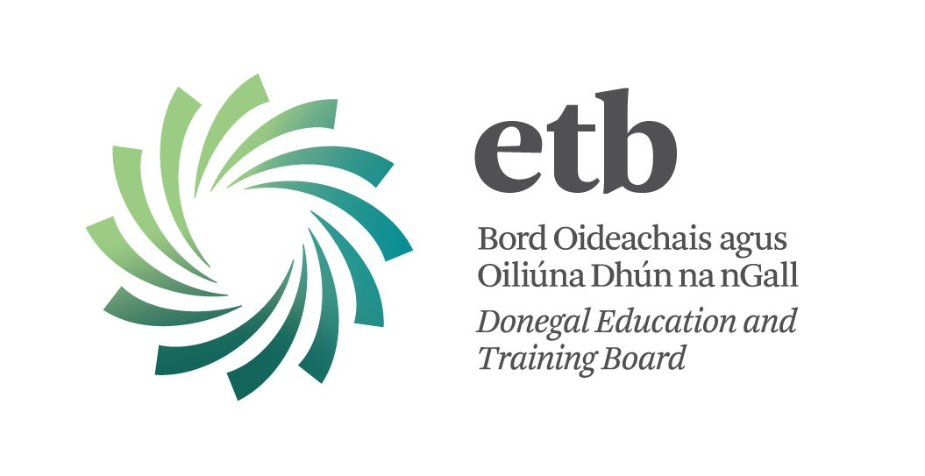

This programme module aims to create awareness of alcohol and other drugs related issues and how these impact on the individual, families and communities. There is a focus on developing theoretical and evidenced based knowledge, together with skills, to enable participants to respond effectively and appropriately to drug and alcohol issues in their work settings or in their families or communities.

LEARNING OUTCOMES: -
→ Understand and explain the process of addiction
→ Outline the impact of Substance Use Disorder on individuals, families & communities
→ Identify key agencies and supports for individuals & families
→ Critically analyse media responses
→ Critically reflect on personal values and belief systems

Starts: 25th February 2016
Mode of attendance: - Thursday evenings plus 3 Saturdays
Time: 6.30pm – 9.30pm
Location: Mayo,Sligo,Leitrim ETB
Closing date for applications: 18th February 2016

Who should attend?
Those that come into contact with alcohol and other drugs as part of their work / volunteering; community workers, counsellors, youth workers, family support workers, nurses, employment support staff, probation, Gardai, among others.
Fee: €300
For an application form email: christinamceleney@donegaletb.ie
For further information: call Christina 0879369312

Dates of attendance Sligo:

START
February | Thurs 25th | 6.30 pm-9.30 pm

March | Thurs 3rd | 6.30 pm-9.30 pm
 | SATURDAY 5th | 10 am – 4.00 pm
 | Thurs 10th | 6.30 pm-9.30 pm
 | Thurs 24th | 6.30 pm-9.30 pm
 | Thurs 31st | 6.30 pm-9.30 pm

April | Thurs 7th | 6.30 pm-9.30 pm
 | Thurs 21st | 6.30 pm-9.30 pm
 | SATURDAY 23rd | 10 am – 4.00 pm
 | Thurs 28th | 6.30 pm-9.30 pm

May | Thurs 5th | 6.30 pm-9.30 pm
 | Thurs 12th | 6.30 pm-9.30 pm
 | Thurs 19th | 6.30 pm-9.30 pm
 | SATURDAY 21st | 10 am – 4.00 pm
 | Thurs 26th | 6.30 pm-9.30 pm

