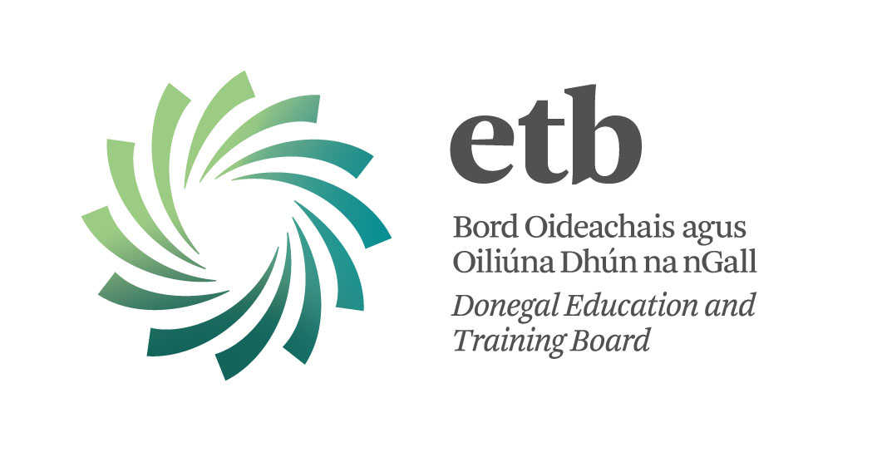

TRAINING CALENDAR

ALCOHOL & OTHER DRUGS RELATED TRAINING

SLIGO LEITRIM
DONEGAL

January – Sept 2015

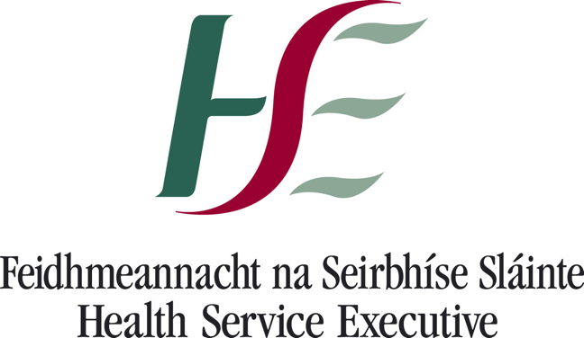
Month | Dates | Training | Location | Places | Page
 | 19 | Drug Type Harms & Effects | Donegal | 16 | Pg. 3
January | 22 | QQI/ Fetac Level 5 in Community  Addiction Studies | Donegal | 16 | Pg. 4
 | 24 | Drug Type Harms & Effects [in service] | Donegal | 16 | Pg. 3
April | 14 | Drug Type Harms & Effects [in service] | Sligo | 16 | Pg. 3
 | 29 | Introduction to Screening & Brief Interventions: Alcohol | Sligo | 12 | Pg. 5
 | 28 | QQI/ Fetac Level 5 in Community  Addiction Studies | Donegal | 7 | Pg. 4
 | 14 | Adolescence and Substance Misuse:  Working with Young People on  Substance Misuse Issues / Early Intervention | Sligo | 16 | Pg. 6
May | 19 | Introduction to CBT | Sligo | 16 | Pg.9
 | 22 | Drug Type Harms & Effects | Leitrim | 16 | Pg. 3
 | 29 | Adolescence and Substance Misuse:  Working with Young People on  Substance Misuse Issues / Early Intervention | Donegal | 16 | Pg. 6
June | 12 | Adolescence and substance Misuse: Working With Young People on Substance Misuse Issues / Early Intervention | Leitrim | 16 | Pg. 6
 | 15 | Introduction to Screening & Brief Interventions: Alcohol | Donegal | 12 | Pg. 5
 | 30 | Introduction to Hidden Harm and the Impact of Substance Misuse on Children & families | Sligo | 16 | Pg. 7
July | 1 | Introduction to Hidden Harm and the Impact of Substance Misuse on Children & families | Donegal | 16 | Pg. 7
 | 8 | Introduction to Hidden Harm and the Impact of Substance Misuse on Children & families | Leitrim | 16 | Pg. 7
 | 16 & 17 | Essential Group Facilitation Skills | Leitrim | 12 | Pg.8
September | 10 | QQI/ Fetac Level 5 in Community  Addiction Studies | Sligo | 16 | Pg. 4
 | 15 | QQI/ Fetac Level 5 in Community  Addiction Studies | Donegal | 16 | Pg. 4
Booking forms are at the end of this document.

Training Calendar:
North West Regional Drug & Alcohol Task Force (NWRDATF) in partnership with Donegal Education & Training Board (Donegal ETB) recently conducted a Training Needs Analysis to ascertain the training needs of the North West Region. The purpose of this work was to determine the training needs of the region, and to develop a calendar of training that would address those needs where possible. The training calendar offers a range of courses on offer. There is also the option of requesting tailored “ in-service’ training for services and organisations, requests will be accommodated to the best of our ability, where possible. The recruitment, design and delivery of the suit of courses have been drawn up in partnership with NWRDATF, Donegal ETB, Alcohol Forum & HSE West (Donegal).

Trainer Profile:
Christina Murray-McELeney completed her BSc Hons Degree with University of Ulster as part of that she studied addictions; she is an educational specialist in the field of alcohol & other drugs having completed her Post Graduate Specialist Diploma in Teaching Learning & Scholarship with University of Limerick. Christina has been voluntarily undertaking courses herself annually for the last 17 years. She has lectured & guest lectured for seven years in various third level institutions namely University of Limerick, North West Regional College, Letterkenny IT and Sligo IT. Christina designs, develops and delivers a range of education & training in the field of alcohol & other drugs and has written third level modules. She works in partnership for the last seven years with the Alcohol Forum and HSE West (Donegal) on specific projects and to ensure the continuance of alcohol & other drugs training & education in the region. She is employed by Donegal Education & Board and is funded by North West Regional Drug & Alcohol Task Force (NWRDATF). Christina was pivotal in the design and delivery of the Midwives handbook & toolkit for the pilot initiative “A Prescription for a Healthy Pregnancy” in Letterkenny General Hospital 2014. Christina is a member of the National Addiction Training Board (NATP), the Alcohol Forum Training & Education Sub-group, Chair of the Prevention & Education Sub-group of NWRDATF and a member of Donegal Education & Training Board Education Pillar. Christina is responsible for coordinating alcohol & other drug education & training in the North West Region. Other trainers may also engage in the delivery of training in the region.

Course Title | Drug Type Harms & Effects Pg. 3
Course Duration: 3 hrs.  Course |  | Date: See below  Date
Who should attend?  Individuals that are coming into contact with Alcohol & Drug issues.  Workers/Volunteers who wish to gain knowledge on alcohol, other drugs and their effects.  People with an interest in this general area. |  | Location:  Raphoe 19th January 2015 [in service]  Ballyshannon 24th March 2015 [in service]  Sligo 14th April 2015 [in service Ballysadare]  Leitrim 22nd May 2015
Number of Places Available: 16 |  | Trainer: Christina Murray-McEleney
Course Description:
An introduction to alcohol, over the counter drugs, prescribed drugs and New Psychoactive Substances (NPS) and their effects plus the main issues surrounding substance use.
Course Content:
A comprehensive introduction to legal, illegal, over the counter (OTC), prescription drugs and New Psychoactive Substances (NPS). Information on the categorisation of drugs and their effects. Exploration of why people use drugs.

Learning Outcomes:
- Participants will be updated and refreshed on the various different familiar drugs & New Psychoactive Substances (NPS)
- Participants will become familiar with the different categories of drugs and why drugs are categorised
- Participants will better understand drug use and develop a harm reduction attitude to substances
- Participants will receive information on the various services that are available for referral

Learning Outcomes:
- Participants will be updated and refreshed on the various different familiar drugs & New Psychoactive Substances (NPS)
- Participants will become familiar with the different categories of drugs and why drugs are catergorised
- Participants will better understand drug use and develop a harm reduction attitude to substances
- Participants will receive information on the various services that are available for referral

Certification / Accreditation:

A Certificate of Attendance will be awarded on completion of the training

Course Title | QQI / Fetac Level 5 in Community Addiction Pg. 4
Course Duration: 54 hrs. taught  96 hrs. self-directed learning  Course |  | Date: Please see overleaf for the range of dates.  Date
Who should attend?  For those that come into contact with alcohol and other drugs as part of their work / volunteering. Counsellors, Social workers, teachers, family support workers, nurses, employment support staff, probation, Gardai among others |  | Location:  Magheraroaty January – April  Sligo Start Date 10th Sept. (evenings)  Letterkenny Start Date 15th Sept. (day time)  See  Le See next page for dates
Number of places available: 20 |  | Trainer: Christina Murray-McEleney
Course Description:
This programme module aims to create awareness of drug/alcohol related issues and impacts on the individual, families and local communities while developing a shared understanding of effective, evidence based community responses.

COur
Course Content: A comprehensive module on all aspects of alcohol & other drugs misuse within communities
Learning Outcomes
- Understand and explain the process of addiction
- Outline the impact of Substance Use Disorder on individuals, families & communities
- Identify key agencies and supports for individuals & families
- Critically analyse media responses
- Critically reflect on personal values and belief systems

Certification / Accreditation:

QQI / Fetac Level 5 Certificate Component
Certification / Accreditation:

September |  |  | October |  |  | November |  |  | December
1 | Tu |  | 1 | Th | SLIGO | 1 | Su |  | 1 | Tu | LETTERKENNY
2 | We |  | 2 | Fr |  | 2 | Mo |  | 2 | We
3 | Th |  | 3 | Sa |  | 3 | Tu | LETTERKENNY | 3 | Th
4 | Fr |  | 4 | Su |  | 4 | We |  | 4 | Fr
5 | Sa |  | 5 | Mo |  | 5 | Th | SLIGO | 5 | Sa
6 | Su |  | 6 | Tu | LETTERKENNY | 6 | Fr |  | 6 | Su
7 | Mo |  | 7 | We |  | 7 | Sa | LETTERKENNY | 7 | Mo
8 | Tu |  | 8 | Th | SLIGO | 8 | Su |  | 8 | Tu
9 | We |  | 9 | Fr |  | 9 | Mo |  | 9 | We
10 | Th | SLIGO | 10 | Sa | LETTERKENNY | 10 | Tu | LETTERKENNY | 10 | Th
11 | Fr |  | 11 | Su |  | 11 | We |  | 11 | Fr
12 | Sa |  | 12 | Mo |  | 12 | Th | SLIGO | 12 | Sa
13 | Su |  | 13 | Tu | LETTERKENNY | 13 | Fr |  | 13 | Su
14 | Mo |  | 14 | We |  | 14 | Sa |  | 14 | Mo
15 | Tu | LETTERKENNY | 15 | Th | SLIGO | 15 | Su |  | 15 | Tu
16 | We |  | 16 | Fr |  | 16 | Mo |  | 16 | We
17 | Th | SLIGO | 17 | Sa |  | 17 | Tu | LETTERKENNY | 17 | Th
18 | Fr |  | 18 | Su |  | 18 | We |  | 18 | Fr
19 | Sa |  | 19 | Mo |  | 19 | Th | SLIGO | 19 | Sa
20 | Su |  | 20 | Tu | LETTERKENNY | 20 | Fr |  | 20 | Su
21 | Mo |  | 21 | We |  | 21 | Sa | SLIGO | 21 | Mo
22 | Tu | LETTERKENNY | 22 | Th | SLIGO | 22 | Su |  | 22 | Tu
23 | We |  | 23 | Fr |  | 23 | Mo |  | 23 | We
24 | Th | SLIGO | 24 | Sa | SLIGO | 24 | Tu | LETTERKENNY | 24 | Th
25 | Fr |  | 25 | Su |  | 25 | We |  | 25 | Fr
26 | Sa |  | 26 | Mo |  | 26 | Th | SLIGO | 26 | Sa
27 | Su |  | 27 | Tu | LETTERKENNY | 27 | Fr |  | 27 | Su
28 | Mo |  | 28 | We |  | 28 | Sa |  | 28 | Mo
29 | Tu | LETTERKENNY | 29 | Th | SLIGO | 29 | Su |  | 29 | Tu
30 | We |  | 30 | Fr |  | 30 | Mo |  | 30 | We
 |  |  | 31 | Sa |  |  |  |  | 31 | Th

Course Title | Introduction to Screening & Brief Interventions (SBI)  Pg. 5
Course Duration: 1 day |  | Date: 29th April 2015 & 15 June 2015
Who should attend?  Staff who have occasion to ask people about their alcohol use. This could include workers from social care, family support, employment support, vocational training, criminal justice, probation, education, housing support and general health care services among others. |  | Loca Location:  Sligo 29th April  Let Letterkenny 15th June  Sligo
Number of places available: 15 |  | Trainer: Christina Murray-McEleney
Course Description: A Brief intervention is amongst the most effective of psychosocial treatments across a range of health related behaviours. It’s a short intervention and consists of a helpful conversation in relation to a person’s alcohol consumption. A substantial body of literature exists which supports the use of a brief intervention in a range of health care settings to be effective in the reduction of problem alcohol consumption. The Steering group report on a Substance Misuse Strategy recommends that SBI training be extended to community, voluntary, health, social and criminal justice settings such as: Health clinics and community-based health services, Community and voluntary services, Mental health services, Educational, criminal justice and other community-based initiatives, Youth and sports organisations; Later life services
Course Content: Evidence for the effectiveness of SBI for Alcohol and drug-related presentations to health, social care and other settings provision of an overview of the SAOR model of intervention for problem alcohol and drug use . Establishing a supportive working relationship with an individual when asking about their alcohol use and how to screen for alcohol use . Deliver a structured brief intervention based upon the SAOR model.
Learning Outcomes
- Critically discuss problem alcohol and drug use as it impacts their current work or area of practice.
- Demonstrate an enhanced knowledge and awareness of contemporary models of screening and brief intervention for problem alcohol and drug use
- Identify problem alcohol and drug users who present to health, social care settings
- Utilise the SAOR model of Screening & Brief Intervention (SBI) in practice based scenarios
- Discuss the application of the SAOR model of screening and brief intervention for problem alcohol and drug use into their practice
- Access useful links and reference materials for further reading and research
Certification / Accreditation:
A certificate of attendance will be awarded on completion of the training.

Course Title | Adolescence and substance Misuse: Working With Young People on Substance Misuse Issues / Early Intervention Pg.6
Course Duration:  COurse |  | Date: 14th May. 29th May. 12th June.  Date
Who should attend?  For those that come into contact with young people as part of their work or voluntary activities alcohol and other drugs as part of their work / volunteering., Social workers, teachers, family support workers, nurses, employment support staff, probation, youth workers Gardai among others. |  | Loc Location:  14th May Sligo  29th May Letterkenny  12th June Leitrim
Number of places available: 16 |  | Trainer: Christina Murray-McEleney
Course Description:
This course aims to create awareness of drug/alcohol related issues and young people The impact of substance misuse on the young person, families and local communities
COur
Course Content:
Learning Outcomes
- Understand teenage brain development
- Understand risk and protective factors
- Outline the impact of Substance Use Disorder on young people , families & communities
- Approach alcohol & drug issues from an informed perspective
- Provide an early brief intervention for alcohol or other drug use
- Identify key agencies and supports for young people experiencing difficulties
Certification / Accreditation:

A certificate of attendance will be awarded on completion of the training.
Certification / Accreditation:

Course Title | Introduction to Hidden Harm and the impact of substance Misuse on Children and families © Pg.7
Course Duration: 1 day  COurse |  | Date: 30th June 2015 & 8th July 2015  Date
Who should attend?  Individuals that are coming into contact with Alcohol & Drug issues.  Workers/Volunteers who wish to gain knowledge on alcohol ,other drugs and their effects. People with an interest in this general area. |  | Loca Location: Sligo 30th June  Sligo Leitrim 8th July
Number of places available: 16 |  | Trainer: Christina McEleney
Course Description: Parental Substance misuse has considerable impact on children and families. Children have a right to be protected from harm, safe from violence and neglect ; treated with love , care, respect and have their wishes taken into account on matters affecting them. Parental Misuse of substances can often result in reduced parenting capacity,unpredictable behaviour, inconsistent parenting, stigma for the family, physical and emotional absence ,possible criminal behaviour.

COur Course Content:
Over
- Introduction to the impact of problem alcohol & other drug use on
parenting capacity
- Understand the interface between alcohol & other drug use
domestic violence, mental health issues and the impact on family
functioning
- Understand familiar drinking patterns, recreational use weekend bingeing, self-medicating, Dependent use , and their possible impact on children

Learning Outcomes:

- Demonstrate a new understanding of problem alcohol & drug use on parenting capacity
- Critically examine personal values and belief systems
- Gain knowledge on the impact on children and family functioning in the context of problem alcohol or other drug use

Certification / Accreditation:

A certificate of attendance will be awarded on completion of the training

Course Title | Essential Group Facilitation Skills Pg.8
Course Duration: 2 days  COurse |  | Date: 16th / 17th July
Who should attend?  This course is aimed at those working in the Community/Voluntary/Drugs/Alcohol sector that are involved in or plan to become involved in the facilitation of a range of groups. |  | Loca Location: Leitrim  L
Number of places available: 16 |  | Trainer: Christina McEleney
Course Description: Facilitation is the theory and practice combined of working with people. Facilitation enables and empowers people to carry out a task or perform an action. A group facilitator uses certain skills in a process which allows the individuals/group reach their decision/ set their goal/learn a skill or what ever the task at hand might be. Facilitation is a developmental educational method which encourages people to share ideas, resources, opinions and to think critically in order to identify needs and find effective ways of satisfying those needs.
COur Course Content:
- To evaluate, recognize and put into practice the theory & practice of group work founded on the principles and values of group facilitation
- How to organise, plan, run and facilitate and evaluate group sessions with parameters, boundaries and group agreements
- Identify power, conflict and lack of participation in a group and how best to manage difficult situations
- Develop an insight into ethical behaviour as a facilitator and the use of your own power in the facilitator’s role
Learning Outcomes:

- Understanding of group task, explicit processes and implicit processes
- Understand influence and power dynamics within a group
- Become an ethical group facilitator
- Plan, provide and manage and evaluate a group session

Certification / Accreditation:

A certificate of attendance will be awarded on completion of the training.

Groups Skills in the Context of Clinical Practice is a follow on 2 day training available from the Alcohol Forum. It also can be available as a 2 day stand alone module for clinical practitioners. Contact Alcohol Forum 074-9125596

Course Title | Introduction to Cognitive Behaviour Therapy Pg.9
Course Duration: 1 days  COurse |  | Date: 19th may
Who should attend?  This course is aimed at those working in the Community/Voluntary/Drugs/Alcohol sector that are interested in CBT. This is a basic introductory course for those considering further training in CBT. |  | Loca Location: Sligo  L
Number of places available: 16 |  | Trainer: Christina McEleney
Course Description: Cognitive behavior therapy is a form of psychotherapy that has been scientifically tested and found to be effective in hundreds of clinical trials for many different disorders. It is a type of psychotherapy that is usually more focused on the present, it is time-limited, and problem-solving oriented. The therapist teaches the client specific skills that they can use for the rest of their lives. CBT involves identifying distorted thinking, modifying beliefs, relating to others in different ways, and changing behaviors. Cognitive Behavioral Therapists use a wide variety of techniques to help patients change their cognitions, behavior, mood, and physiology. CBT has been effective for a range of problems including depression, anxiety, panic disorder, anger, self-esteem,obsessive compulsive disorder and substance abuse.
COur Course Content:
- Introduction to the model of CBT
- How the perception influence emotions and behaviour
- Identification of automatic thoughts that cause problematic feelings and behaviours
Learning Outcomes:

- Client - counsellor relationship/ therapeutic alliance
- Understand the basic concepts of CBT
- Understand the collaborate nature of CBT
Certification / Accreditation:

A certificate of attendance will be awarded on completion of the training.

NOTES:

Each training session is subject to numbers. The training calendar is subject to change.

Booking is essential TWO weeks before any short courses to ensure numbers are adequate.

Booking is essential FOUR weeks before the QQI / Fetac level 5 in Community Addictions.

Tailored training can be designed and delivered in service by request.

A booking form is available at the back of this document, it can be printed off and posted or it can be completed and emailed.

A “request for tailored training” form is also available at the end of this document. Again it can be posted or emailed.

Please contact Christina for any further enquires:

Tel : 0749161508

Mob: 0879369312

Email : christinamceleney@donegaletb.ie

Booking Form
Name of Course
Date & Location of Course
Individual applicant details

Name
Tel / Mob
Address
Email Address
Organisation applicant details

Name of contact person
Oganisation details
( briefly describe your organisation and what it does)
Contact Tel / mob
Contact email address
Application for Training
Have you previously completed any alcohol and other drugs training?
(Please describe)

What do you hope to learn from this training?

(Please Describe)

You can print this form and post it to: Christina Murray-McEleney, Coordinator Alcohol & Other Drugs Education & Training, NW region, Donegal ETB, Ard O’ Donnell, Letterkenny, Donegal.

Or, You can email this form to: christinamceleney@donegaletb.ie
Please note all training schedule is subject to minimum numbers
Request for tailored in-service training
Course requested
Possible dates
Organisation details

Name of contact person
Oganisation details
(briefly describe your organisation and what it does)
Contact Tel / mob
Contact email address
Please provide a much detail as possible for your particular request
What other alcohol / drug training has your organisation completed?
Please provide a rationale for the training you request
Post to: | Christina Murray-McEleney, Coordinator Alcohol & Other Drugs Education & Training , NW region, Donegal ETB, Ard O’ Donnell, Letterkenny, Donegal.
Email to: | christinamceleney@donegaletb.ie

