**Workshop is aimed at providing information for those who work with clients at risk from using drugs and alcohol.**

**Workshop will refresh and update participants knowledge on the range of psychoactive substances and the impact of these substances on the brain and body. It will enable participants to identify signs and symptoms of alcohol and drug misuse as well as providing participants with information on early interventions and referral pathways.**

TRAINING WORKSHOP

Date 15th of October 2013

Venue : Peter Kennedy Chamber Donegal PSB

Donegal County Council Donegal Town

Time: 10.30-12.30 and 1.30-3.30

RSVP tmitchell@nwdrugtaskforce.ie

Dr

**Drug, Types Harms and Effects Training Workshop**

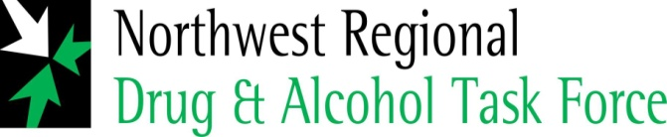

consulting

